Introduction

- Data Types: In programming language, it is a set of data with the values having pre-defined characteristics.
- System/Compiler defines data types are called primitive data types.
- Structure in C/C++ & classes in C++/Java are the means to create our own data types known as user define data types.
- Making categery of data is imp..(int, char, float) to efficently perform operations on it.
- User defined data types are made using primitive data types.
- ex- if we want to store info.. of student(name, age, DOB).
If we want to store info.. of book(Name, price, Year).

- Data Structure: It is a perticular way of storing & organizing data in a computer so that it can be used efficiently.
- The idea is to reduce the space &time complexities of diff.. tasks.
- The choice of a good data structure make it possible to perform a variety of critical operations effectively. An efficient data stucture also uses minimum memory space & execution time to process the structure.
- There are 2 types of Data Stucture:

- Linear Data Structure: Data structure in which data elements are arranged sequentially or linearly, where each element is attached to its previous and next adjacent elements, is called a linear data structure. Elements are arranged in 1D.
ex- lists, stack, queue, etc.

- Non-Linear Data Structure: Data structures where data elements are not placed sequentially or linearly are called non-linear data structures. In a non-linear data structure, we can’t traverse all the elements in a single run only. Elements are arranged in one-many, many-one and many-many dimensions.
ex- tree, graph, table, etc.

Abstract Data Type (ADT)

- All primitive data types supports basic operations like addition, subtraction, etc.
- The system is providing the implementation for the primitive data types.
- For non primitive data types we also need to define operations.
- Combination of data structure and their operations are known as Abstract Data Types.
- So Data Structure is all about creating Abstract data type.
- Any piece of information can be handled by defining appropriate data types and set of possible operations.
- But how those operations are working that is totally hidden from the user.
- Implementation part is hidden from the user.

- Abstract means “existing in thought or as an idea but not having a physical or concrete existence i.e.. theoretical”.

Abstract data types model:

- Abstraction: It is a technique of hiding the internal details from the user and only showing the necessary details to the user.

- Encapsulation: It is a technque of combining the data and the member function in a single unit is known as encapsulation.
Ex – Some operations on stack ADT -:
- isFull ()
- isEmpty ()
- push (x)
- pop ()
- peek (), used to get top most elements of stack.
- Size ()

- Data Structure are used in verious fields such as:
- Operating System
- Graphics
- Computer Design
- Blockchain
- Genetics
- Image Processing
- Simulation etc..

Q. Diff b/w Data Types & Data Structure.
= Data Type: It defines that the particular variable will assign the values of the given data type only.
- There is no time complexity in the case of data types.
- It is pre-defined keyword or datatypes having its pre-defined operations.

Data Structure: It is a collection of diff.. kind of data. That entire data can be represented using an object.
- It can hold multiple types of data within a single object.
- It has time-complexity, which plays an imp.. role.
- It is made using primitive data types.
- It is user-defined & has user-defined operations.

Classification of Data Structure:
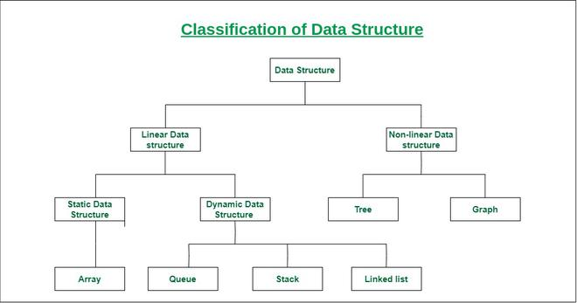

Static D.S: Static D.S has a fixed memory size. It is easier to access the element in it.

Dynamic D.S: The size is not fixed. It can be randomly update during the runtime which maybe considered efficient concerning the memory complexity of the code.

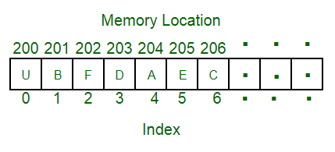

storing a list of items having the same data-type using the array data structure.

